EX:No.10 221501044

Develop vector auto regression model for multivariate time series data forecasting.
Aim:
Write a program to develop vector auto regression model for multivariate time series data forecasting.

Algorithm:
1.Import necessary libraries:
Import numpy, pandas, matplotlib.pyplot, VAR from statsmodels.tsa.api, and mean_squared_error from sklearn.metrics.
2.Load the dataset:
Read the weather data CSV file, parse the 'Date' column as datetime, and set it as the index.
3.Select multiple relevant columns:
Choose important features for multivariate analysis like 'Temperature', 'Humidity', and 'WindSpeed'.
4.Handle missing values:
Use forward fill method (ffill) to fill in any missing values in the dataset.
5.Split the data into training and testing sets:
Reserve the last n observations for testing (e.g., n_obs = 10), and use the rest for training the model.
6.Fit the VAR model:
Initialize the VAR model with the training dataset and fit it to learn interdependencies among the variables.
7.Forecast future values:
Forecast the next n_obs steps using the trained VAR model.
Convert the forecasted values into a DataFrame with the same structure as the original data.
8.Visualize actual vs. forecasted values:
For each selected variable (e.g., Temperature, Humidity, WindSpeed), plot the actual and forecasted values on the same graph.
9.Evaluate model performance:
Calculate the Root Mean Squared Error (RMSE) between actual and forecasted values for each variable.
10.Display the RMSE values.

Code:

import numpy as np
import pandas as pd
import matplotlib.pyplot as plt
from statsmodels.tsa.api import VAR
from sklearn.metrics import mean_squared_error

# Load the dataset
try:
df = pd.read_csv("/content/MSFT.csv", parse_dates=['Date'], index_col='Date')
except KeyError:
# If 'Date' column is not found, try using 'Month'
try:
df = pd.read_csv("/content/MSFT.csv", parse_dates=['Month'], index_col='Month')
except KeyError:
print("Error: Neither 'Date' nor 'Month' column found in CSV for parsing dates.")
exit(1)

# Check if 'Close' column exists, otherwise print available columns
data_column = None
if 'Close' in df.columns:
data_column = 'Close' # Use 'Close' for Microsoft stock data
else:
print("Error: 'Close' column not found in CSV. Available columns:")
print(df.columns)
exit(1)

# Create synthetic multivariate dataset using lag features
# We'll use 'Close' as the main data column
df['Close_lag1'] = df[data_column].shift(1) # Lagged Close price
df['Close_diff'] = df[data_column].diff() # Difference in Close price

# Drop initial NaN values caused by shifting
selected_data = df[[data_column, 'Close_lag1', 'Close_diff']].dropna()

# Forward fill if needed (generally clean after diff/shift)
selected_data = selected_data.fillna(method='ffill')

# Forecast horizon
n_obs = 10
df_train = selected_data[:-n_obs]
df_test = selected_data[-n_obs:]

# Fit VAR model
model = VAR(df_train)
model_fit = model.fit()

# Forecast
forecast = model_fit.forecast(df_train.values[-model_fit.k_ar:], steps=n_obs)
forecast_df = pd.DataFrame(forecast, index=df_test.index, columns=selected_data.columns)

# Plotting actual vs forecasted
for column in selected_data.columns:
plt.figure(figsize=(10, 4))
plt.plot(df_test[column], label='Actual')
plt.plot(forecast_df[column], label='Forecasted')
plt.title(f'Microsoft Stock Price Forecasting - {column}') # Title updated
plt.xlabel(df.index.name)
plt.ylabel(column)
plt.legend()
plt.grid(True)
plt.tight_layout()
plt.show()

# Print RMSE
for column in selected_data.columns:
rmse = np.sqrt(mean_squared_error(df_test[column], forecast_df[column]))
print(f'RMSE for {column}: {rmse:.2f}')

Output:

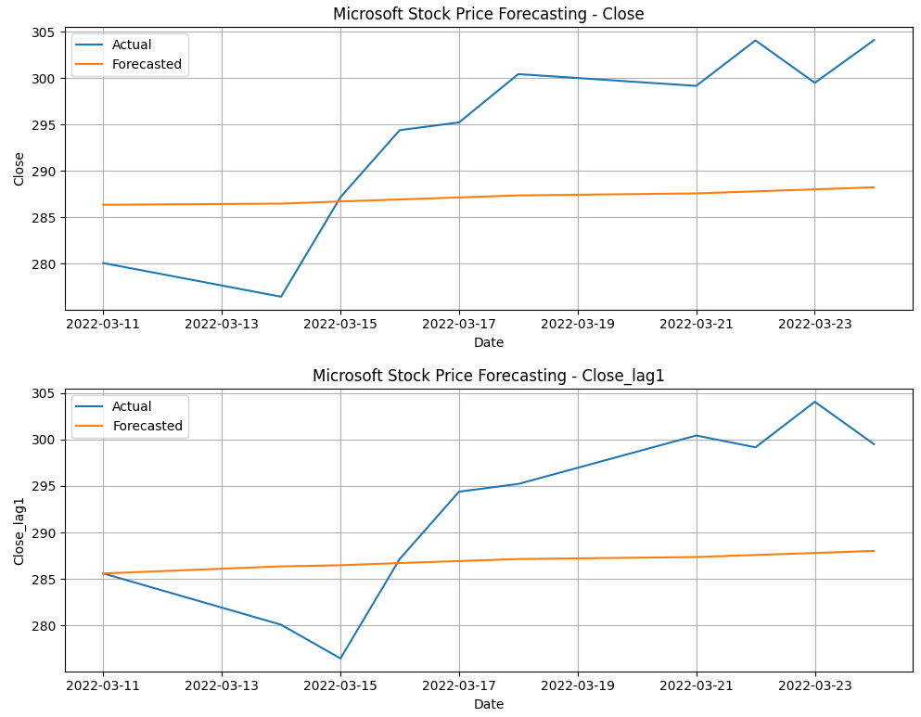
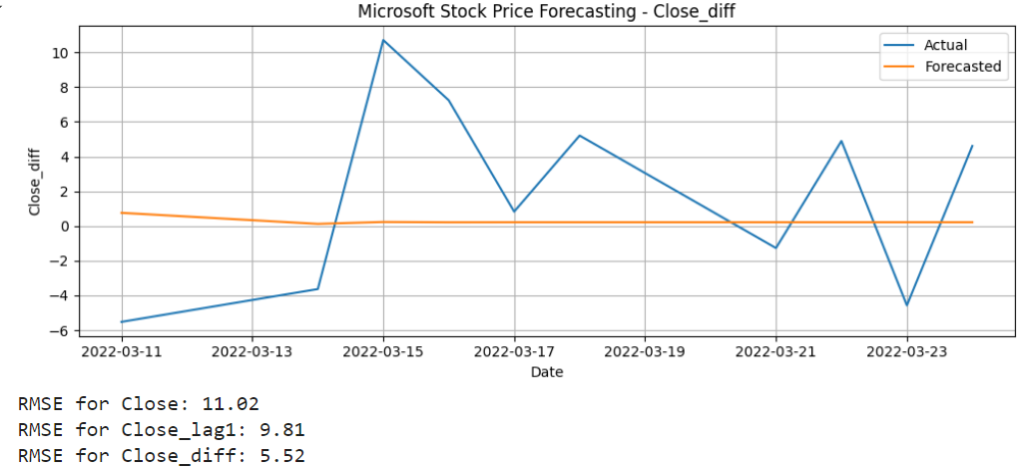
Result:
Thus, the program to develop vector auto regression model for multivariate time series data forecasting was done.

